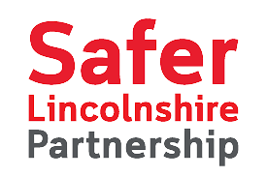

L I N C O L N S H I R E C O N C O R D A T

S U P P O R T I N G W O M E N A N D G I R L S A T R I S K O F E N T E R I N G T H E C R I M I N A L J U S T I C E S Y S T E M

We commit to work together to improve outcomes for Lincolnshire women and girls at risk of entering or who have already entered the criminal justice sector. These women and girls, often with multiple and complex needs, include some of the most vulnerable in our county. We will work together to address their needs, preventing trauma from happening or promoting recovery if trauma has been experienced already. In so doing we will apply the principles of the Lincolnshire Women’s Strategy in the provision and commissioning of all services in Lincolnshire. We will make sure that all our services and partners, including the voluntary sector, work together to support women and girls. We will promote the delivery of the strategic priorities of the Ministry of Justice Female Offender Strategy, which should result in:

fewer women coming into the criminal justice system.
fewer women in custody (especially on short-term sentences) and a greater proportion of women supported in the community successfully.
better conditions for those who are in custody.

As part of our commitment we agree to report, when required by the signatories of the National Concordat and then on an annual basis, the steps we have taken and for that information to be available alongside the Lincolnshire Women's Strategy, which will be hosted on the Lincolnshire Police and Crime Commissioners website.

N A M E

O R G A N I S A T I O N

S I G N A T U R E

